KINDERGARTEN
HANDBOOK

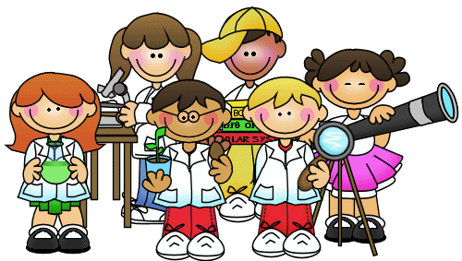

ST. AMBROSE ACADEMY
31 EMPIRE BLVD.
ROCHESTER, N.Y. 14609
585-288-0580

WEB SITE: http://stambrose.academy
E-MAIL: saadcs@dor.org

MISSION STATEMENT
St. Ambrose Academy nurtures foundational skills of spiritual, academic, and social growth, creating leaders of HOPE for our local and global communities.

Our schools:
- Lead students to be disciples who know and live the Catholic faith.
- Inspire a learning community to foster academic excellence; and
- Motivate young people to fulfill the two great commandments of Jesus Christ by loving God and self in order to be responsible and give service to our neighbor.

VISION STATEMENT
With Jesus as our role model, strive to prepare children to become faithful, contributing, compassionate lifelong learners of the global community.

- Academics:
  - We offer educational experiences that encompass NYS curriculum and develop creativity, initiative and love for learning.
  - To enhance academic excellence, technology is integrated throughout the curriculum.
  - We provide academic enrichment, as well as extracurricular opportunities, for students throughout the year.
  - We provide academic intervention services at all grade levels.
  - Students develop an understanding of and an appreciation for the visual and performing arts, and build the foundation for an active and healthy lifestyle.

- Catholic Identity
  - Catholic identity is the foundation for all that we do.
  - Through daily prayer and various liturgical experiences, students develop a strong prayer life and a personal relationship with God.
  - We provide family members the opportunity to participate in the faith formation of their children.
  - Clergy from Peace of Christ Parish and other area churches participate in the faith formation of our children.
  - Our Catholic education fosters Christian values and ethical conduct that are fundamental to society.

- Citizenship
  - Our school embraces diversity as an expression of God’s creativity.
  - As a human being created in God’s image and likeness, every individual is respected by others.
  - All children have a right to learn in a safe, supportive and stimulating environment which provides them with a sense of belonging.
  - Service to the community is rooted in the commandment of Jesus to love one another. Our school provides opportunities for students to give back to the community.
  - The success of our school is a collaboration of teachers, parents, the parishioners, community, and area businesses.

How Parents and Guardians Can Support and become more involved?

St. Ambrose Academy invites anyone interested in taking an active part in their child’s education to volunteer and to join a committee. Contact the school office for more information.

PARENT AND GUARDIAN VOLUNTEER PROGRAM
Parents and guardians are invited to share their time and talents at school after they have taken the on-line Creating a Safe Environment (CASE)Workshop. Please contact the school office for more information. Volunteers are needed for recess and lunch.

PARENT-TEACHER CONFERENCES
Conferences are scheduled in November with all parents. Spring conferences are scheduled at parents’ or teachers’ request. However, a parent may request a conference at any time by calling the school and making an appointment.

*Please refer to the Covid-19 Reopening Plan for possible modifications to volunteer opportunities.

IS MY CHILD READY TO BEGIN SCHOOL?

When children move into Kindergarten, they enter a classroom with one teacher and many children. There are skills that may help children adjust to this new setting. The following is offered as a guideline to help you determine if your child is ready to begin school life. Some of these skills include:
To stay on task and follow directions
To understand that there are rules that need to be followed
To be comfortable in a group of children
To show an interest in books and be able to maintain attention for stories
To have experience with the following tools: scissors, pencils & crayons
To write his/her first name and attempt last name
To ask for help and to sense what is appropriate to ask and when
To wait for one’s turn
To share the teacher’s attention
To care for classroom materials and to share them
To make transitions even when not ready
To care for oneself dressing and toileting
To care for personal property –coat, boots, mittens
To make things work -- buttoning, tying, working puzzles
To express themselves clearly in conversations with children and adults
To control one’s emotions

How Can I Help My Child?

- Build a relationship with your child’s teacher.
- Talk with the teacher about how your child is doing:
    - Ask specific questions about your child’s progress.
    - Does my child understand the parts of a book?
    - Can he or she retell a simple story in their own words?
    - Is my child engaged during story time?
    - Can he or she count and tell the number of objects?
    - Can he or she solve addition or subtraction problems?
    - Ask to see a sample of your child’s class work and then ask questions about the work such as:
          - Is this satisfactory work?
          - Is my child on track?
          - How can I help my child improve or excel in this area?
          - If my child needs extra support or wants to learn more about this subject, are there resources to help him or her outside the classroom?

What activities can I do at home to support learning?

- Read with your child every day!
- Ask your child to explain his or her favorite parts of the story.
- Share your ideas.
- Encourage your child to tell you about his or her day at school.
- Play word games like I spy, sing songs and make silly rhymes together.
- Look for word problems in real life.
- Create patterns with household objects.
- Ask your child questions that require counting as many as 20 things.
- Ask your child questions about comparing numbers. “Who has more books, you or your sister?”

Sample Daily Schedule
Breakfast
Prayers/Pledge/Announcements
ELA (English Language Arts)
Special class

Lunch

Recess

Math

Listening/Science/Social Studies

Religion

Dismissal

**The schedule can vary due to special subject classes or special activites.

Special Subject Classes
Art class is once a week.
Technology class is once a week.
Physical Education class is twice a week.
Library is once a week.
Music is once a week
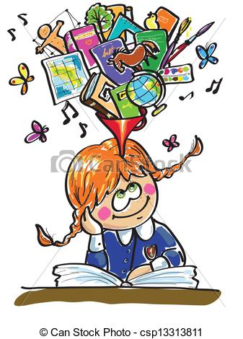

Kindergarten
Parent Guide to
Common Core State Standards

This guide will provide a general overview of what your child will learn in English Language Arts/Literacy and Mathematics by the end of Kindergarten. If your child is meeting the expectations outlined by the Common Core State Standards (CCSS), he or she will have a strong foundation for first grade.

A sample of what your child will be working on in Kindergarten

English Language Arts / Literacy Mathematics
- Upper and lower case letters,
matching letters with their sounds, and writing letters.
- Listening to stories and comparing the experiences of familiar characters.
- Retelling stories, learning to extract details from the text.
- Describing events through drawing, dictating and writing.
- Stating their opinion about a topic or piece of literature.
- Understanding and using question words (who, what, where, when, why and how)
- Asking and answering questions about key details in text.
- Speaking clearly to express their thoughts and opinions.
- Identify the front and back cover and title page of a book.
- Follow words from left to right, top to bottom and page by page.
- Phonics and word recognition
- Counting objects to tell how many there are.
- Count to 100 by ones and tens.
- Write numbers from 0 to 20
- Represent a number of objects with a written numeral 0 – 20
- Count to tell the number of objects
- Count to tell how many objects
- Identify greater than, less than or equal in sets of objects.
- Compare numbers
- Understanding addition as putting together and adding to
- Understanding subtraction as taking apart and taking from.
- Work with numbers 11-19 to gain foundations for place value.
- Describe and compare measurable attributes of objects (length, width)
- Identify and describe shapes (squares, circles, cones, cylinders and spheres).

RELIGION

Our Religion program focuses on helping the children to understand that they are a unique and special created in the image and likeness of God. In addition to helping the children develop positive attitudes about themselves, the other goals of the religion program include:

Helping young children learn about a loving God through the
gift of creation.

Increasing the children’s appreciation for their five senses as
gifts from God.

Helping young children develop a friendship with Jesus.

Introducing the children to liturgical seasons and helping them
prepare for the religious celebrations of Christmas and
Easter. The children attend and plan school wide Masses throughout the school year.

Teaching young children about prayer and showing them how to
pray. The children learn the Sign of the Cross, Our Father,
Hail Mary and Grace before meals during the year.

Helping young children learn about the Christian attitudes of
taking turns, listening, helping, caring, sharing, loving, thanking
and celebrating.

Young children learn best through active experiences -stories, songs, and prayers.

OUR KINDERGARTEN SOCIAL STUDIES CURRICULUM

The Kindergarten Social Studies curriculum focuses primarily on the study of self, home, school, the community and special holidays, concepts of geography, creating and understanding of the past and identifying situations in which social actions are required.

There are three major goals of the Kindergarten Social Studies curriculum:

To develop positive self- concept
To understand the similarities and differences between people
To understand that they are unique and special individuals, and yet they share similar feelings and concerns with others

Studies Weekly Magazine enhances the Social Studies curriculum.

*******************************************************************

OUR KINDERGARTEN SCIENCE CURRICULUM

Children at this age learn best through observation, experimentation and exploration. We incorporate those three types of learning in the Science themes we cover.

Major Science topics include:

Seasons Health
Our Body Five Senses
Animal Life Life Cycles (Plant and Animal)

Science is integrated into all areas of Kindergarten - from the stories we read to the field trips we take.

KINDERGARTEN LIBRARY

Kindergarteners attend library classes once a week. The librarian reads to the children and helps them become familiar with the library. Also, we talk about the care and handling of books.

- The students may borrow one book each week. All books are due on a specific day of the week.
- Notices will be sent home with the students prior to this time, so you will be aware of their schedule.
- Remind your child to take care of the book she/he borrows.
- Have your child consistently keep it in a safe place, away from younger brothers and sisters.

*Please refer to the Covid-19 Reopening Plan for possible modifications to the borrowing of library books.

LUNCH PROGRAM

The children receive free breakfast and lunch. They may preorder a hot lunch at the beginning of the month or bring their lunch. They may sit where they want at the Kindergarten tables, which allows for more socialization.

*Please refer to the Covid-19 Reopening Plan for possible modifications to seating arrangements in the lunch room.

FIELD TRIPS

Field trips augment the curriculum that is being taught in the classroom. Previous field trips have included trips to the apple farm, plays at Nazareth College, visits from local fire and emergency crews, a zoo trip, and Strong Museum. Virtual field trips may also be available.

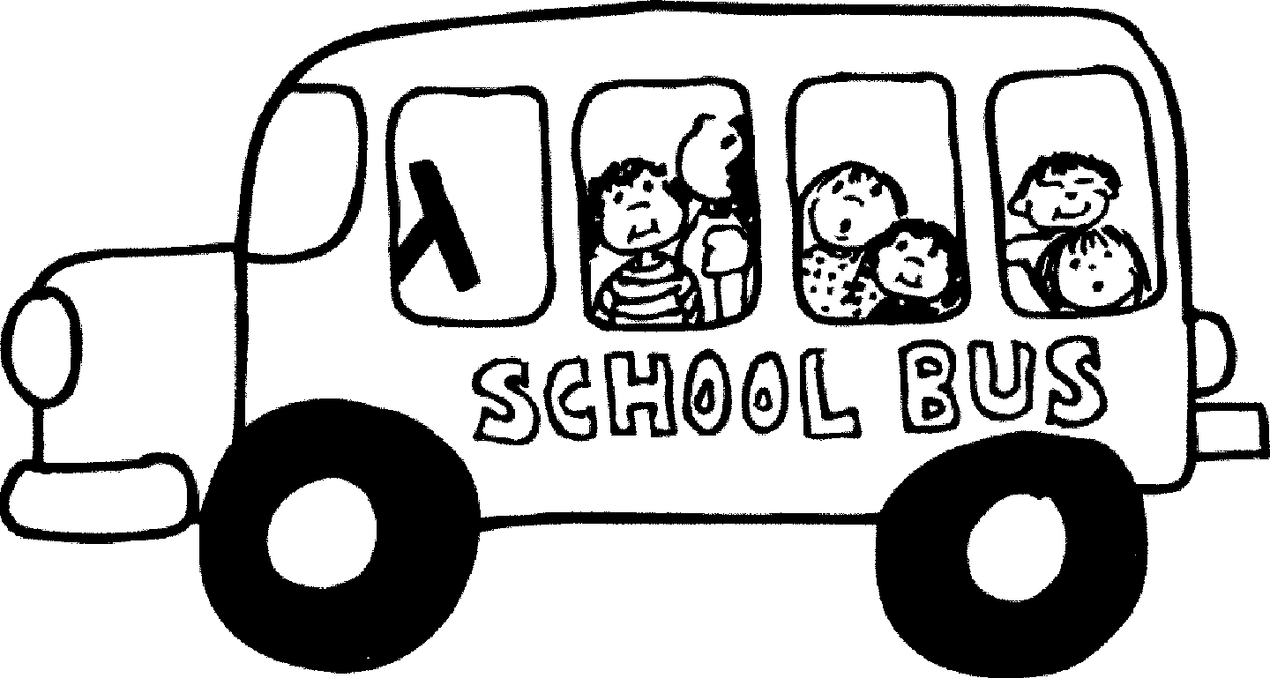

*Please refer to the Covid-19 Reopening Plan for possible modifications to the scheduling of field trips.

